WireFu

Game Documentation

By

Hwan Jung

Jason Ko

Ulysses Villagomez

# WireFu

## Copyright Information

The development of this game will be for educational purposes in learning about game design. The use and demonstration of this game may be used for educational purposes. Some of the content within the game such as artwork, music, and sounds have been borrowed and will be utilized under the Fair Use law of the U.S. Code: 17 U.S.C. § 107.

# Section I: Project Overview

## Team Personnel

Hwan Jung – [hjung5@masonlive.gmu.edu](mailto:hjung5@masonlive.gmu.edu)

Jason Ko – [jko5@masonlive.gmu.edu](mailto:jko5@masonlive.gmu.edu)

Ulysses Villagomez – [uvillago@masonlive.gmu.edu](mailto:uvillago@masonlive.gmu.edu)

### Design team

#### Design lead

Jason Ko

#### Level designer

Ulysses Villagomez

#### Art

Jason Ko

#### Sound and Music

Hwan Jung

### Programming team

Hwan Jung

Jason Ko

Ulysses Villagomez

## Executive Summary

### High concept

Become the star of a martial arts movie as you fly around the set beating up thugs with the over-the-top powers of wire-fu to create awe-inspiring stunts for fame and fortune.

### The Hook

This game has good flow due to physics-based platforming, which will build on our background of working with physics in games. Having to perform a long string of linked abilities to maximize score also helps with flow, in contrast with platformers like Super Mario Brothers which force the player to wait while elements in the level fall into place.

### Story Synopsis and Setting

It's time to shoot your latest film. The director wants something even crazier than your last one. Strive to show off your martial arts prowess by maintaining the longest takes possible in a city and studio environment to create long combos of fluid movements without messing up.

### Genre

Physics-based action platformer

### Visual Style

2D side-scroller

### Engine

Pygame with Pymunk physics

## Core Gameplay

Run through the set, a complex obstacle course of props and bodies, trying to keep your momentum up. Clearing the entire level in one fluid run will result in a higher score. Fly by around the environments to maintain flow. Leap across platforms and slide on slopes. Don't forget to show off a bit for your fans by using any spare time to throw a few more punches and kicks, for effect. The flashier and smoother you perform, the more money you will earn. Falling off of the set will prompt the director to offer you the chance to continue, as he can just cut the footage together later. Doing so may help you nail the harder scenes, but will deny you the fame of a true master of wire-fu, who would be able to the whole scene in one take. Rejoice at the end of a completed scene and bask in the admiration of your fans, as well as the director.

## Game Feature

Most other platformers which utilize acceleration are slow-paced (N, SMB3). WireFu will be fast-paced and fluid.

## Project Scope

### Number of distinct locations

There will be 3 distinct areas in the game: city, general movie studio, American Gladiator-like studio.

### Number of levels/missions

10 levels

### Number of NPCs

None

## Target Audience

People who yearn for the ability to meld the showmanship of skateboarding or free running in a fast-paced platformer requiring good hand-eye coordination.

## Delivery Platforms

The game will be developed to work on both Linux, and 32-bit Windows. On 64-bit Windows systems, the 32-bit version of Python will need to be installed.

# Section II: Story, Setting, and Character

## Story

It's time to shoot your latest film. The director wants something even crazier than your last one. Strive to show off your martial arts prowess by maintaining the longest takes possible (create long combos of fluid movements without messing up).

## Environments

### Area #1

#### General description

Levels 1 and 2 will be fairly flat and easy for the player to become acclimated with the controls and environment. Levels 3 and 4 will require good jumping and ramp sliding skills.

#### Physical characteristics

Tall buildings and rivers that need to be crossed.

#### List of levels that take place in this area

Levels 1, 2, 3, and 4

### Area #2

#### General description

A movie studio. The player has moved from the city to the studio to prove his skills to the director.

#### Physical characteristics

More out of the ordinary items due to the fact that movie studios have everything they need to make extraordinary special effects. There will be wires (ziplines) that allow the character to “fly” across the area.

#### List of levels that take place in this area

Levels 5, 6, 7, and 8

### Area #3

#### General description

The American Gladiator studio. The player must show off his top speed and skills to the director to make his grand ideal movie authentic. There will be a lot jumping and ramps that the player would need to master in order to complete the level successfully.

#### Physical characteristics

There will be crazy situations where the player will need to be quick with the jumping such as several short successive platforms and ramps. This area will truly test all the skills the player acquired in the previous areas.

#### List of levels that take place in this area

Levels 9 and 10

## Characters

### Player Character

The character is a fast moving kung-fu movie star. When given the space to run, he can accelerate to blazing speeds. He’s also capable of making long jumps while moving at high speeds. The need for speed is in the character’s blood and he loves showing off his moves, especially when it comes to jumping on and off platforms. The faster he can move the more he knows he will satisfy his director and make a great film.

### Animation

The character will be able to walk and speed up to a full out sprint. The walking and gradual increase of speed will need to be animated. Jumping and whizzing across the ziplines must also be included in the animations.

# Section III: Combat

## Powerups

### Jump powerup

* Jump height
* Double jumps

# Section IV: Controls

* Move Left: Left Arrow
* Move Right: Right Arrow
* Jump: Spacebar
* Pause/Un-pause: P
* Restart Level: R
* Volume Up: 1
* Volume Down: 2

# Section V: Interface

## Camera

This will purely be a 2D platformer game. The camera will always follow the character as he moves throughout the levels.

## Menus

### Game screen flow diagrams

### Main Menu

#### New Game

Begins the game.

#### Options

* Music: Left-click to enable or disable the music. Press ‘1’ to increase the volume or ‘2’ to decrease the volume
* Sound: Left-click to enable or disable sound effects (e.g. – pickup powerup)

#### Credits

This will display the developers of the game and any artworks, sounds, and music borrowed from other sources.

#### Exit

Quits the game.

# Section VI: Artificial Intelligence

None needed for this game.

# Section VII: Detailed Level/Mission Descriptions

## Level 1

### Synopsis

Level one is an introductory level allowing the player to familiarize himself with the controls of the character. A single ramp and zipline are also introduced here.

### Mission objectives (player goals)

The objective of the level is to reach the finish platform (yellow) as quickly as possible.

### Physical description

Apartment suburban area

### Map (concept)

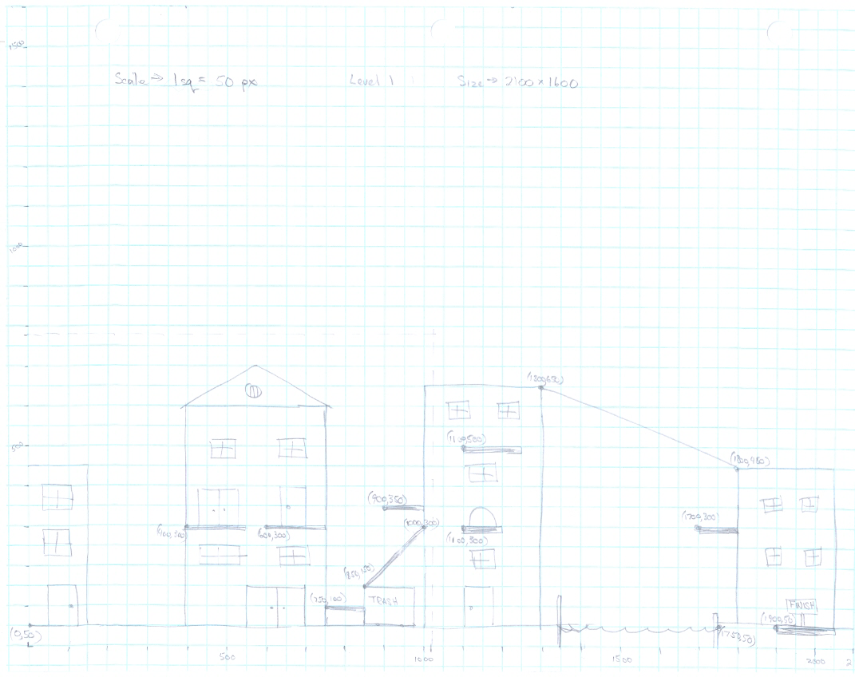

### Powerups

None.

## Level 2

### Synopsis

The player is introduced to the Jump powerup in this level, and more jumping skills will be required to complete the level.

### Mission objectives (player goals)

The objective of the level is to reach the finish platform (yellow) as quickly as possible.

### Physical description

Apartment suburban area

### Map (concept)

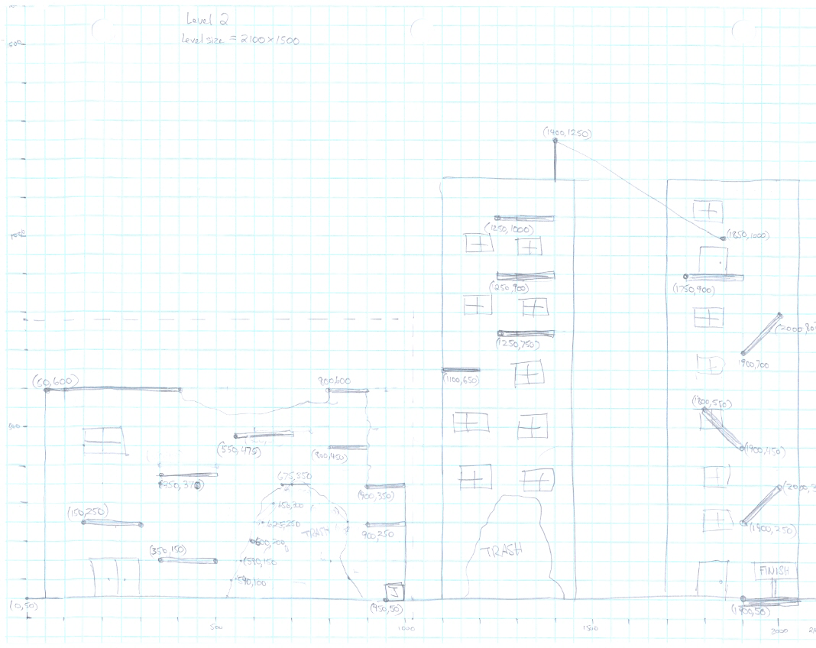

### Powerups

One Jump powerup.

## Level 3

### Synopsis

The player is now forced to jump up a skyscraper to show off his jumping skills but never forgetting that reaching the end quickly scores high with his director and audience. The use of the zipline can be used to help the player move quickly from one end to the other.

### Mission objectives (player goals)

The objective of the level is to reach the finish platform (yellow) as quickly as possible.

### Physical description

Climbing skyscrapers.

### Map (concept)

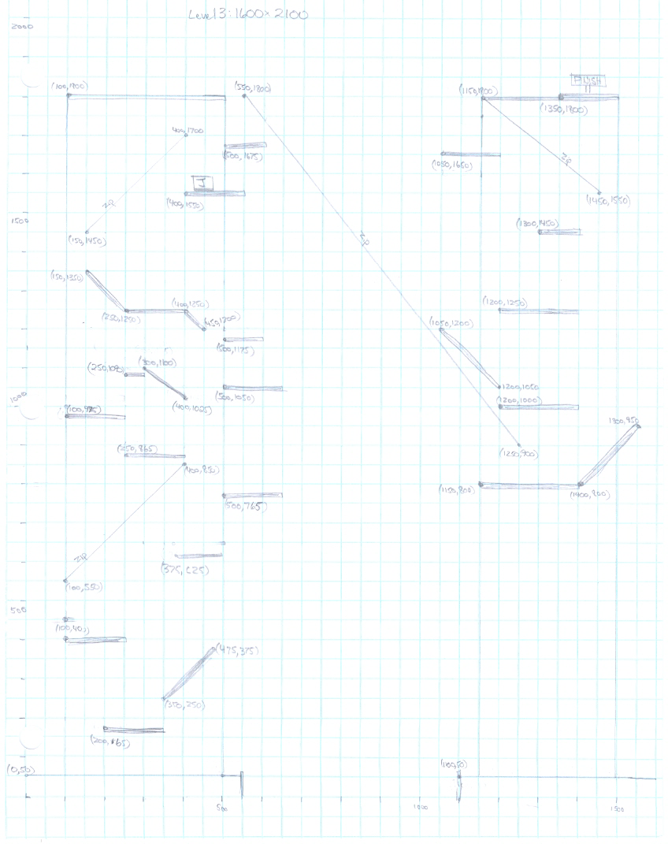

### Powerups

One Jump powerup.

## Level 4

### Synopsis

This level takes place up high on the buildings, meaning there is no ground platform. The player may fall to his “death” if he does not carefully make his jumps.

### Mission objectives (player goals)

The objective of the level is to reach the finish platform (yellow) as quickly as possible.

### Physical description

Up high on the buildings.

### Map (concept)

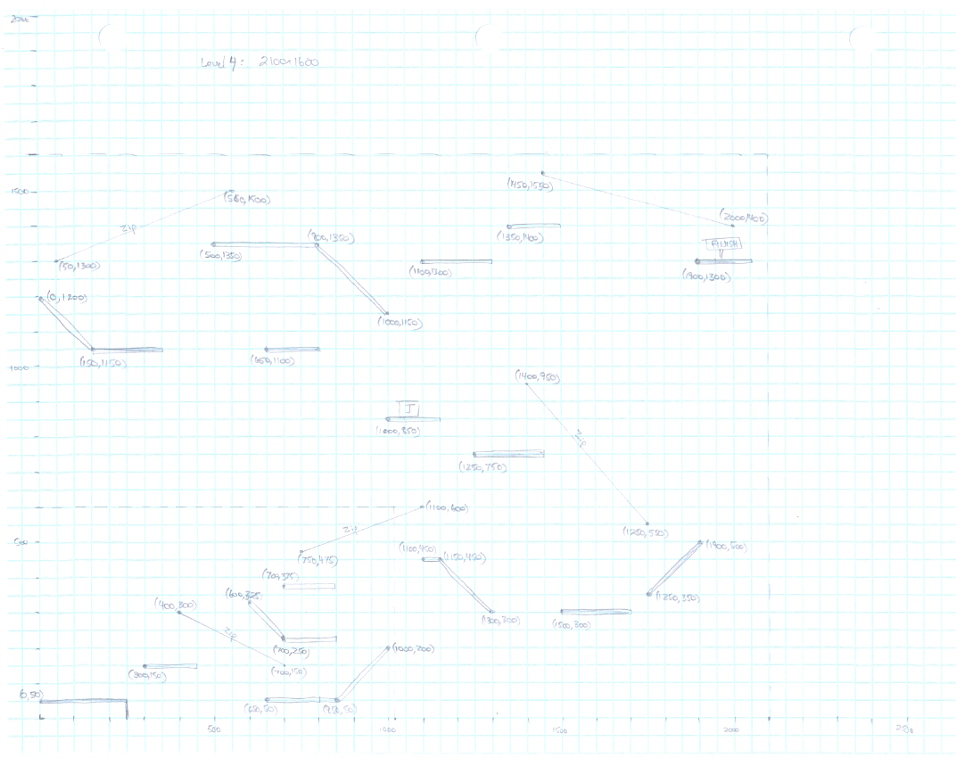

### Powerups

One Jump powerup.

# Section VIII: Game Modes

This is a single-player game.

## Rules

The player will begin the level in the idle position. The clock begins to run as soon as the player moves the character. The faster the player can reach the victory condition the higher he will score.

## Death and restarts

The character does not actually die but gets to redo the scene if he falls from too high of an altitude or if he falls off the level. When this occurs, the character will restart the level from the beginning and the clock will also be reset to zero. If the player becomes stuck or he just wishes to restart the level, he may do so by pressing ‘r’.

## Victory condition

The character must touch the yellow platform at the end of the level to stop the clock. At this point, he will receive a score.

# Section IX: Asset List

## Art

The artwork and animations for the character will be created during development. Tile artwork for walls, windows, doors, and other items will be obtained from the Internet since we do not have dedicated art designers.

## Sound

### Environmental sounds

* Powerup consumed
* Victory

## Music

### Ambient

* Loop #1: Run the blockade
* Loop #2: Follow Me

### Action

* Loop #1: spin - <http://www.newgrounds.com/audio/listen/481538>

# Section X: Major Event Planning

The introduction of the game will be given in a game design class at George Mason University on April 25, 2012. The game will be explained in full details about the character, levels, and gameplay. The method on how the game was designed and the vision we are going for at release time. A prerelease demo will also be demonstrated.

# Section XI: Technical Summary

## PC

* System requirements: Windows 32-bit or Linux 32-bit/64-bit
* Recommended system requirements: Windows 32-bit or Ubuntu Linux 64-bit